HOW TO INSTALL THE SYSTEM

1.Download and Install XAMPP

Link: <https://www.apachefriends.org/download.html>

1. Click both Start ( Apache and MYSQL)

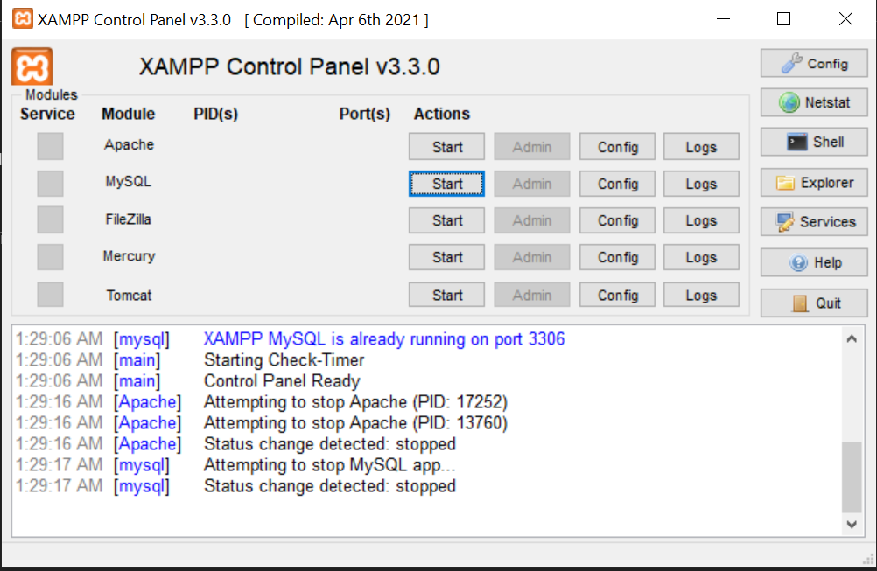

1. Also click explorer and you will be redirected xamp folder open htdocs folder and paste the project here

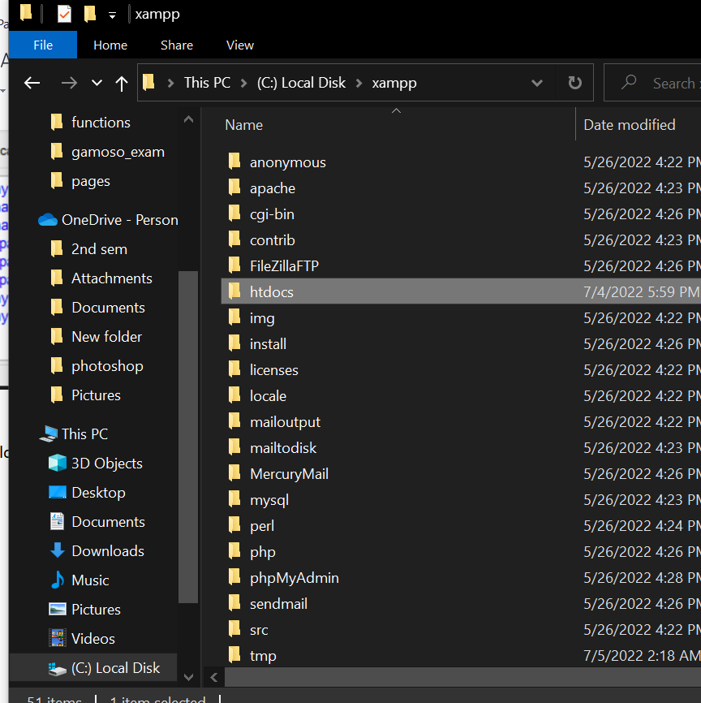

3. After clicking start open any browser and go to

Link: <http://localhost/phpmyadmin/>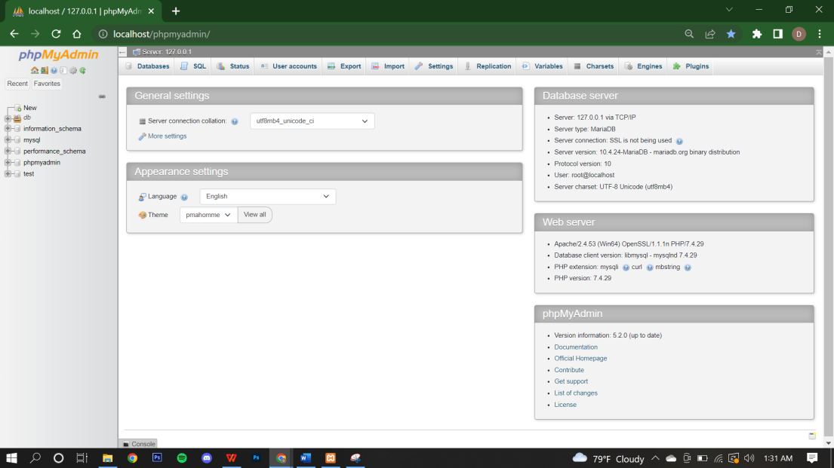

4. Click new

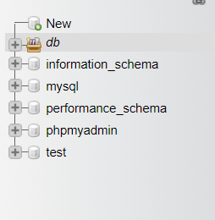

5. Create database with name “db_dost” then click create

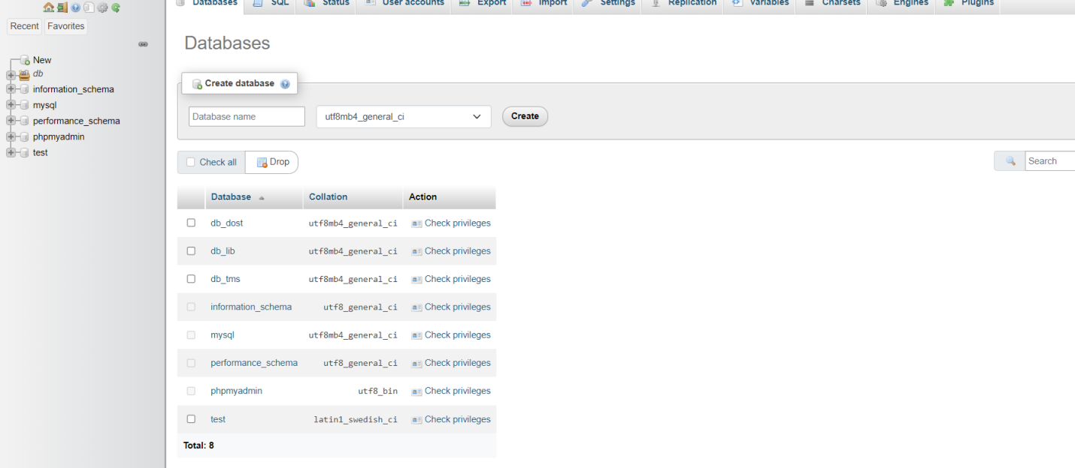

6. go to import

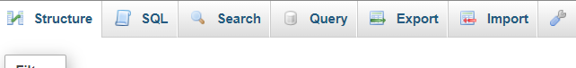

7. choose db_dost and click import

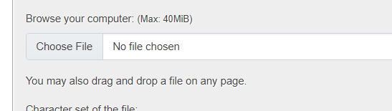

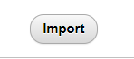

8. go to any browser and enter <http://localhost/gamoso_exam/index.php>

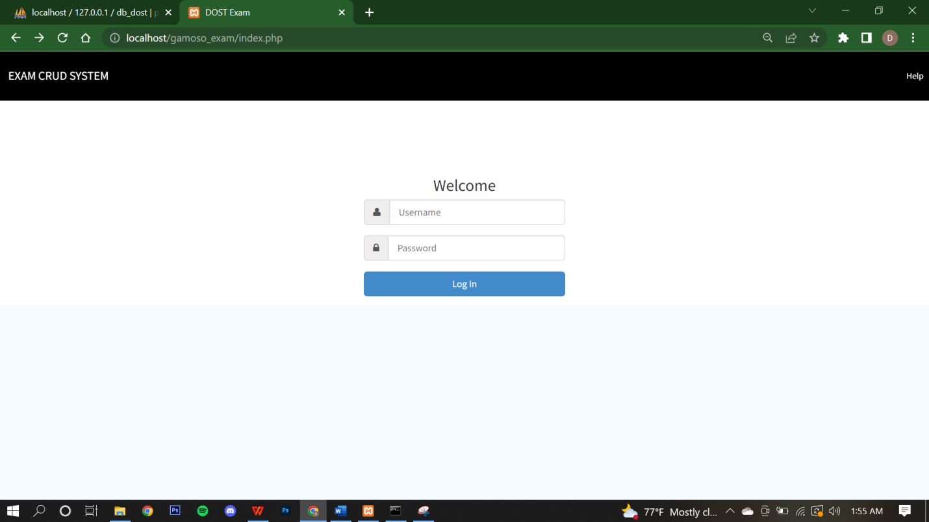

9. The Default account is

Username: admin

Password: admin

After logging in you will be directed here

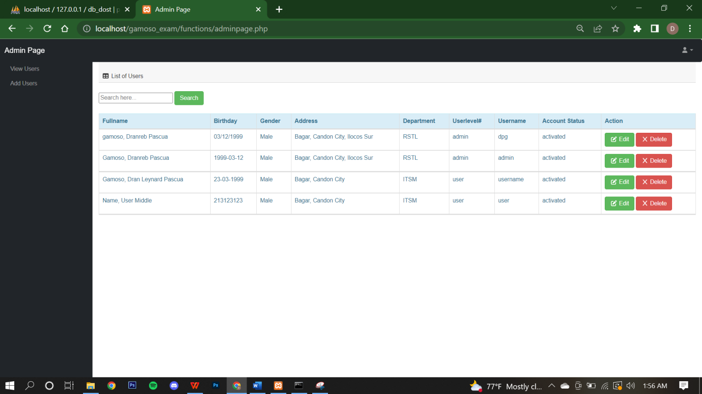

10. To add User click Add user

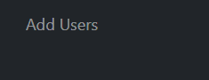

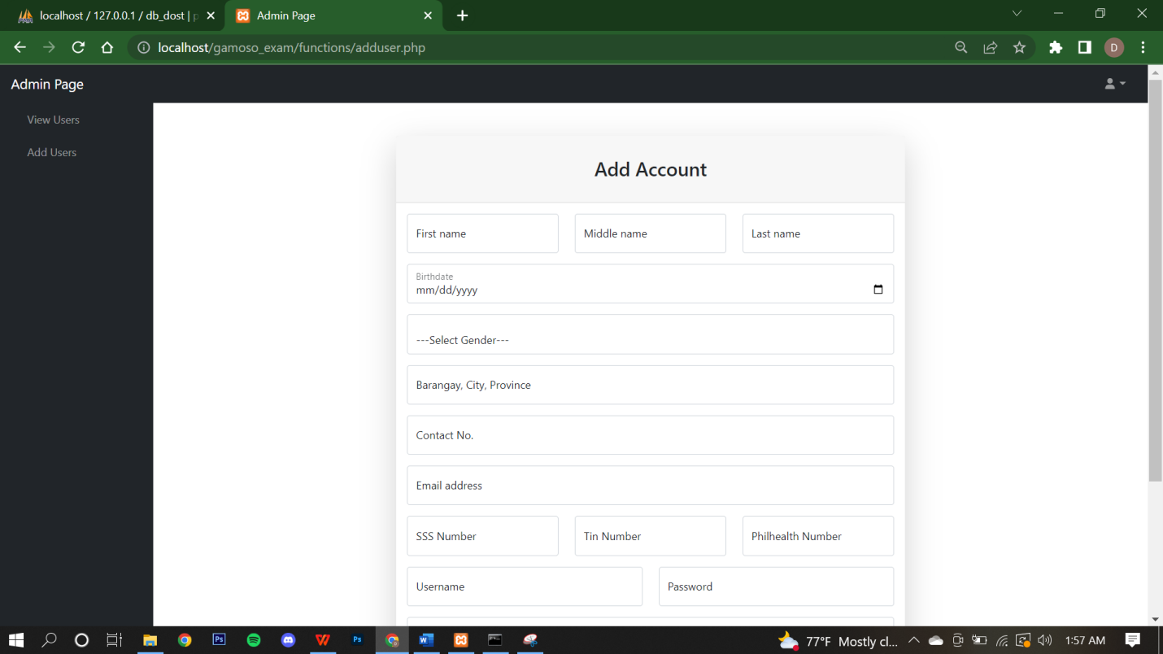

After adding you can go to View User to view All list.

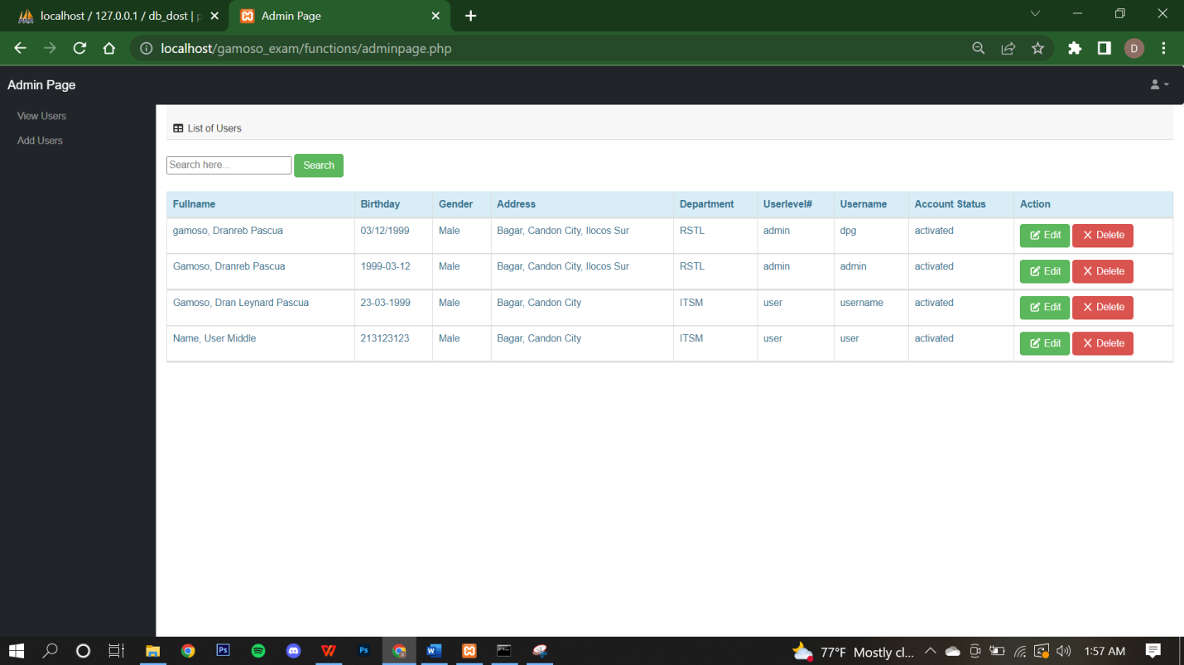

To Edit details just click the edit button of their names

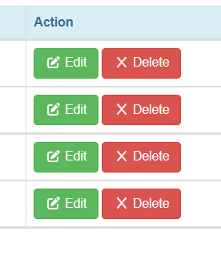

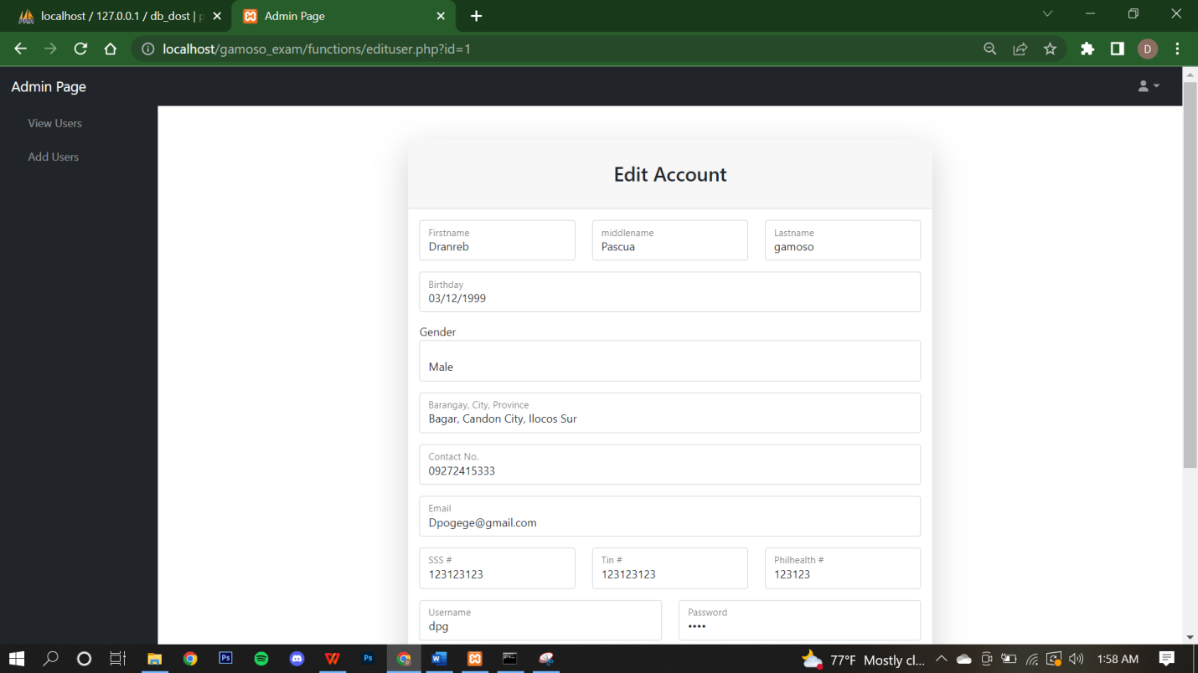

You can disable the users account thru changing user level to deactivated.

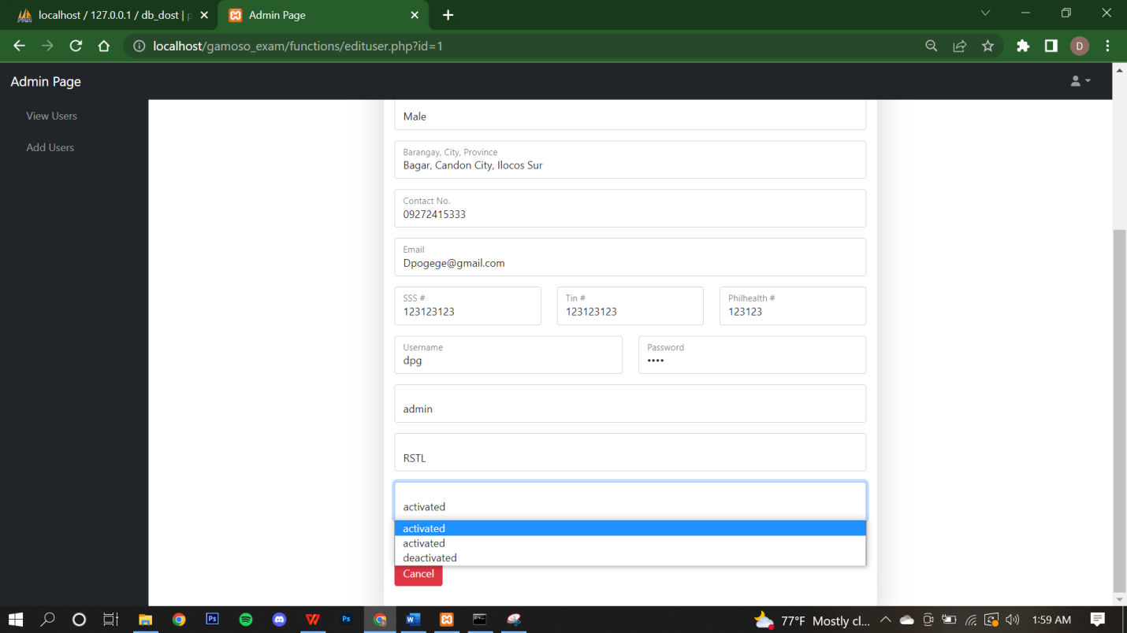

After that click Update

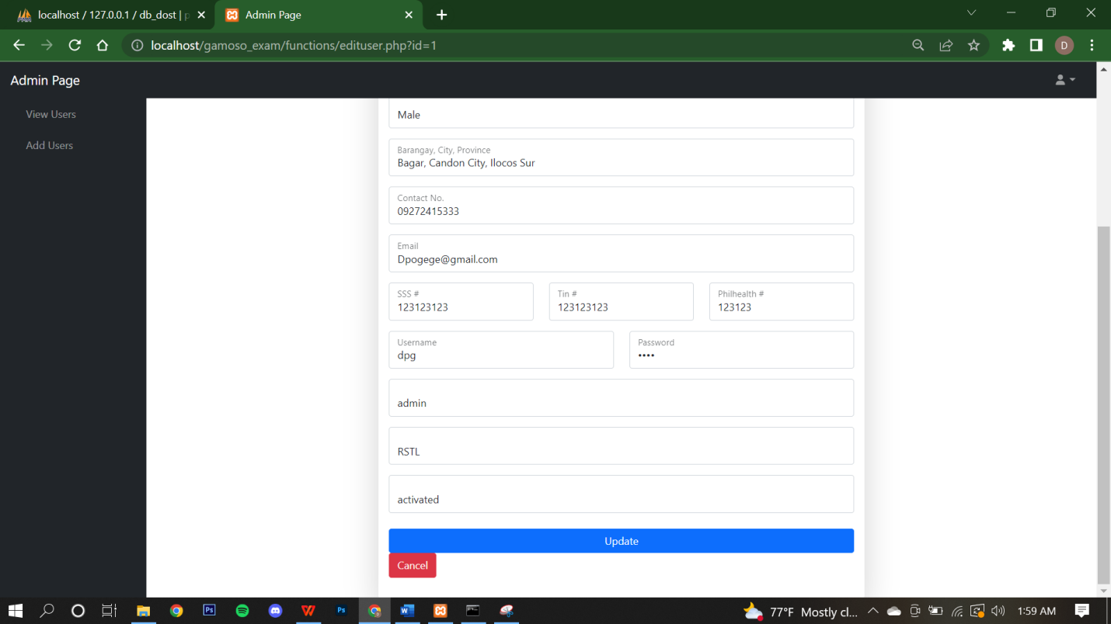

In userlevel user you can only edit some details.

